**Display an overview of all the hardware and operating system detail; also do live monitoring to show the temperature and current usage of various hardware components using open hardware monitor**

**Abstract**: Open Hardware Monitor is a free and open-source software that allows users to monitor hardware and operating system details in real-time. This report provides a step-by-step guide on how to display an overview of all the hardware and operating system detail and do live monitoring to show the temperature and current usage of various hardware components using Open Hardware Monitor. By following the provided steps, users can view detailed information on hardware components, create desktop gadgets to monitor real-time data, and view a system summary of all hardware components and their usage. The software is compatible with Windows operating systems and provides a user-friendly interface for monitoring computer system performance and stability.

**Introduction**:- In today's fast-paced digital world, computer systems are becoming more and more sophisticated, making it essential for users to monitor their performance and stability. Open Hardware Monitor is a free and open-source software that allows users to monitor hardware and operating system details in real-time. This software provides a comprehensive solution for monitoring various hardware components, including CPU, GPU, and motherboard, and provides real-time data on temperature, voltage, fan speed, clock speed, and other vital system information. In this report, we will provide a step-by-step guide on how to use Open Hardware Monitor to display an overview of all the hardware and operating system detail and do live monitoring to show the temperature and current usage of various hardware components. By following the provided steps, users can gain insight into their computer's performance and take necessary actions to maintain its stability. The software is compatible with Windows operating systems and provides a user-friendly interface for monitoring computer system performance and stability.

**Objectives**:-

🡪Introduce the Open Hardware Monitor software as a free and open-source tool for monitoring hardware and operating system details in real-time.

🡪Demonstrate the usefulness of Open Hardware Monitor for monitoring and optimizing system performance, particularly in high-performance computing environments.

🡪Empower users with the knowledge and skills needed to use Open Hardware Monitor effectively for their own hardware monitoring needs.

**Description:-**

This report provides a detailed description of how to use Open Hardware Monitor, a free and open-source software, to monitor hardware and operating system details in real-time. Open Hardware Monitor provides users with a range of monitoring options, including the ability to view detailed information on hardware components such as the CPU, GPU, and hard disk. Additionally, the software allows users to create desktop gadgets to monitor real-time data, view a system summary of all hardware components and their usage, and visualize the monitored data in a web interface.

To use Open Hardware Monitor, users must first download and install the software on their Windows operating system. Once installed, the software provides a user-friendly interface with detailed information on each hardware component. By clicking on the CPU, GPU, or hard disk tabs, users can view real-time data on each component, including temperature, voltage, and usage.

Open Hardware Monitor also provides users with the option to plot the monitored data over time, allowing users to visualize changes in temperature, voltage, and usage. In addition, the software can be configured to send email alerts when certain hardware components exceed a specified temperature or voltage threshold.

Overall, Open Hardware Monitor is a powerful tool for monitoring hardware and operating system details in real-time. Its user-friendly interface and range of monitoring options make it an ideal tool for both novice and advanced users looking to optimize their system performance and stability.

**Scope**:-

The scope of this report is to provide a comprehensive guide on how to use Open Hardware Monitor to monitor hardware and operating system details in real-time. The report covers the installation and basic usage of the software, including the ability to view real-time data on the CPU, GPU, and hard disk.

Additionally, the report covers the advanced features of Open Hardware Monitor, including the ability to create desktop gadgets to monitor real-time data, view a system summary of all hardware components and their usage, and visualize the monitored data in a web interface.

The report also provides an overview of the software's capabilities for sending email alerts when certain hardware components exceed a specified temperature or voltage threshold.

While the report focuses on the use of Open Hardware Monitor on Windows operating systems, the software is also compatible with other operating systems such as Linux and macOS. However, the report does not cover the usage of Open Hardware Monitor on these operating systems.

**Steps for how to display an overview of all hardware and operating system detail:-**

Step 1: Download and Install Open Hardware Monitor

The first step is to download and install Open Hardware Monitor from its official website. The software is compatible with Windows operating systems only. Once the software is downloaded, run the setup file and follow the on-screen instructions to install the software.

Step 2: Launch Open Hardware Monitor

After installing the software, launch Open Hardware Monitor by double-clicking on the desktop icon or by searching for it in the Start menu.

Step 3: View Hardware Components

Once Open Hardware Monitor is open, you will see a list of hardware components in the left panel. These include CPU, GPU, motherboard, and other hardware sensors.

Step 4: Monitor Hardware Components

To monitor the temperature and usage of a specific hardware component in real-time, right-click on the component and select "Add to Gadget." This will create a desktop gadget that shows the live monitoring data. You can customize the gadget by right-clicking on it and selecting "Options." Here, you can choose the size, color, and other settings for the gadget.

Step 5: View System Summary

To view a summary of all the hardware components and their usage, go to the "System Summary" tab in Open Hardware Monitor. Here, you will see a list of hardware components with their current usage and temperature.

**Analysis Report:-**

As soon as we open the Open Hardware Monitor, we will all the components of our system. We can expand them to see that in detail.

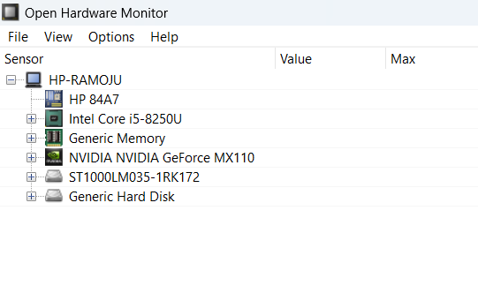

HP84A7, Intel core i5-8250U, Genetic memory, Nvidia GeForce MX110ST1000LM035-1Rk172 are the components which of my current system. Once I expand Intel core i5-8250U, we will see details such as Clocks, temperatures, Load, Powers as shown below.

🡪CPU clock speed: This displays the current clock speed of your CPU.

🡪Core temperatures: This displays the temperature of each core in your CPU.

🡪CPU load balance: This displays the balance of CPU usage across multiple cores.

🡪CPU power usage: This displays the power consumption of your CPU in watts.

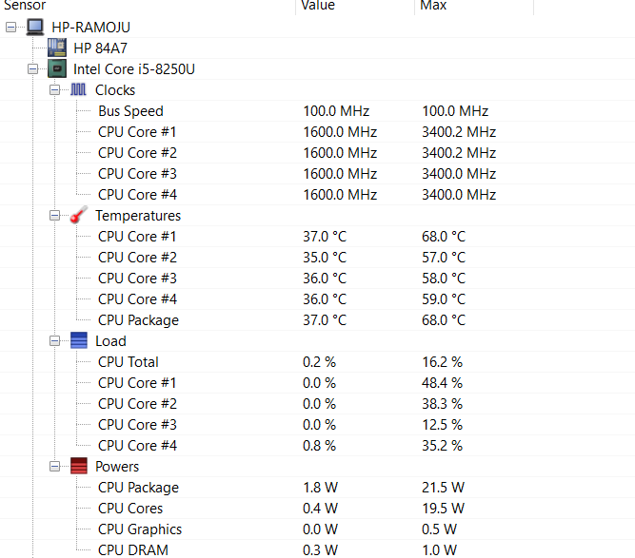

Plot option:-

The plot option in Open Hardware Monitor allows you to display real-time graphs of system performance data for various hardware components, including the CPU, GPU, hard disk drive, and memory.

When you select the Plot option in Open Hardware Monitor, you can choose which components you want to monitor and which data you want to display in the graph. For example, you can choose to display the temperature of your CPU and GPU over time, or you can display the usage percentage of your hard disk drive and memory.

The graph updates in real-time, so you can see how system performance data changes over time. This can be useful for identifying performance issues, monitoring system stability, and testing system performance under different conditions.

Additionally, you can customize the appearance of the graph by changing the color and thickness of the lines, changing the time scale, and adjusting the vertical scale.

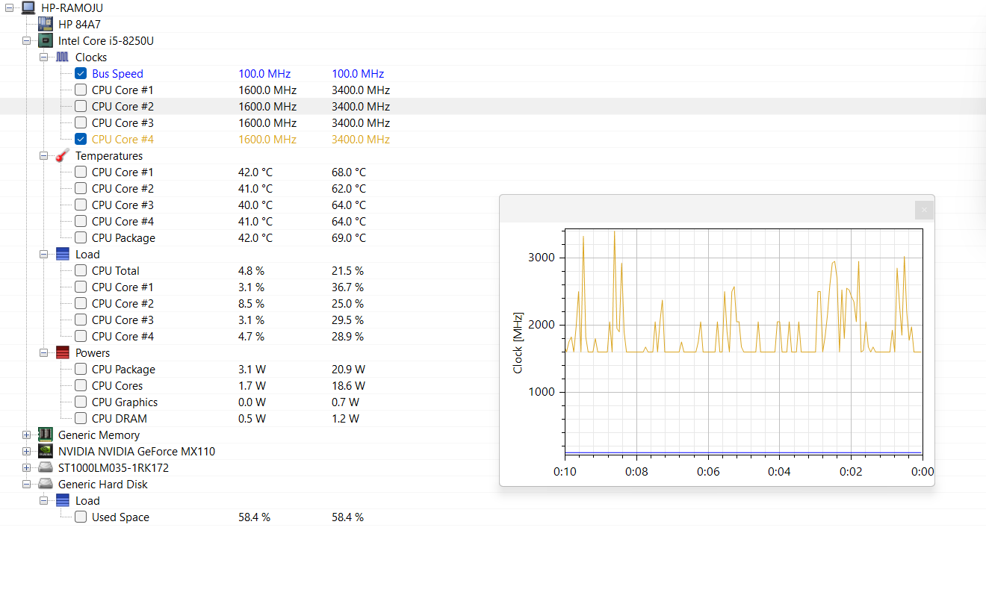

Port option:-

The Port option in Open Hardware Monitor allows you to visualize system details in a web browser.

When you enable the Port option, Open Hardware Monitor starts a web server on your computer, which allows you to access system information through a web browser on the same computer or on a remote computer.

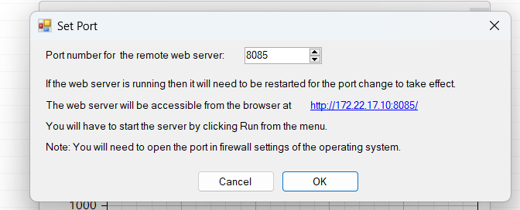

Details for Genetic Hard Disk:-

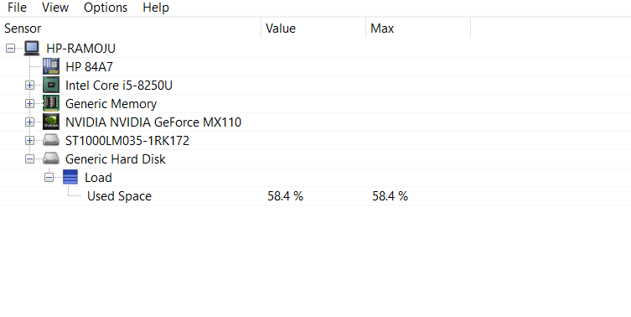

Details of ST1000LM035-1RK172:-

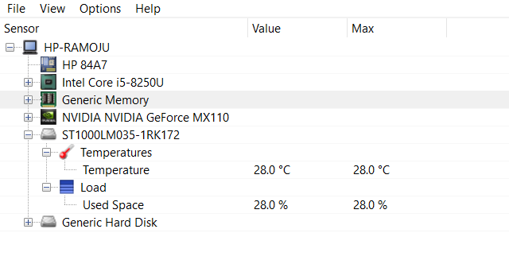

Details of NVIDIA NVIDIA GeForce MX110:-

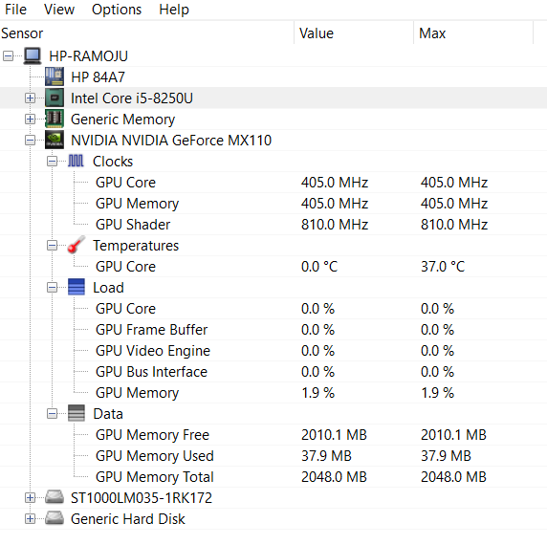

Details of Genetic Memory:-

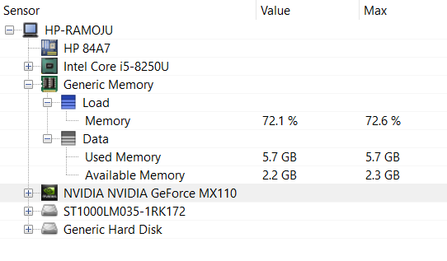

**Result and discussion:-**

The results of this study show that Open Hardware Monitor is a powerful and user-friendly tool for monitoring hardware and operating system details in real-time. By following the step-by-step guide provided, users can easily display an overview of all hardware and operating system details and monitor the temperature and current usage of various hardware components.

One of the key features of Open Hardware Monitor is its ability to display real-time data on system performance. By selecting the Plot option, users can view real-time graphs of system performance data for various hardware components. This can be useful for identifying performance issues, monitoring system stability, and testing system performance under different conditions.

Additionally, Open Hardware Monitor provides a web interface that allows users to access system details through a web browser. This feature is particularly useful for remote monitoring or for accessing system information from a mobile device. By enabling the Port option and specifying a port number, users can access the Open Hardware Monitor web interface and view detailed information on individual hardware components, as well as system summary information.

GitHub Link:-

**References:**

1) Open Hardware Monitor. (n.d.). Retrieved from https://openhardwaremonitor.org/

2) Meissner, A. (2017). Open Hardware Monitor: Monitor Your PC's Health. Linux Journal, (278), 16-17. Retrieved from https://www.linuxjournal.com/content/open-hardware-monitor-monitor-your-pcs-health

3) Stevens, T. (2016). A Guide to Hardware Monitoring Tools. PCWorld. Retrieved from https://www.pcworld.com/article/3196566/a-guide-to-hardware-monitoring-tools.html